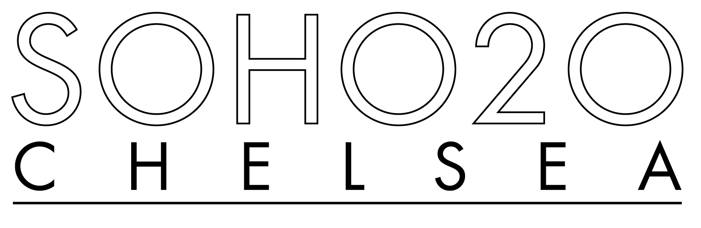

547 W. 27th Street,
Suite 301
New York, NY 10001
(212) 367-8994
(212) 367-8984 fax
Tues. – Sat. 12 – 6PM
info@soho20gallery.com
www.soho20gallery.com

Since 1973, a gallery promoting the work of women artists and serving the community through public events

FOR IMMEDIATE RELEASE

Hungry Eyes:
New Work By SOHO20 National Affiliate Artists
June 24- July 19, 2014

SOHO2O CHELSEA GALLERY
547 West 27th Street, Suite 301
New York, NY 10001

Opening Reception: Thursday, June 26, 6:00-8:00 PM

Brown Bag Roundtable: Wednesday, June 25, 6:00-8:00 PM
Rules of Success: What Is Allowed---and What do We Allow Ourselves?
With artists Elizabeth Michelman, Fran Bull, Barbara Rehg, and Nelleke Nix

B. Amore (Vermont) http://www.bamore.com  Fran Bull (Vermont) www.franbull.com  Louise Farrell (Massachusetts) www.louisefarrell.com  Elizabeth Michelman (Massachusetts) www.elizabethmichelman.com  Gail Hoffman (New York)  Nelleke Nix (New York/Washington) http://www.nnix.com  Barbara Rehg (Georgia) http://www.brehgstudios.com  Ann Rowles (Georgia) www.annrowles.com | Georgia Strange (Georgia) www.georgiastrange.net  Rosie Thompson (North Carolina) http://www.frankisart.com/rosie-thompson  Virginia Tyler (North Carolina)  Mary Whalen (Michigan) www.marywhalen.com  Laura Cloud (Michigan) www.art.msu.edu/profile/cloud‎  Karen Baldner (Indiana) www.karenbaldner.com  Eve Whitaker (Texas) www.evewhitaker.com www.buttonpettergallery.com

For information please contact gallery director Dana Harrison at 212.367.8994 or email at info@soho20gallery.com

What hunger does art seek to satisfy? Can it reconnect us to an early paradise of comfort and fullness? Or must it always remind us that we are forever needful and lacking? For some, art appeals to an appetite for pleasure, pure and simple. For others, it’s a simulacrum or critique of our more complex desires, forcing us to reconsider our values through a throbbing, multisensory, multidimensional experience of the cultural world. In Hungry Eyes, the images, objects, and formal explorations of thirteen women artists take widely divergent views of yearning.

The Artists and Their Work

Soho20 Gallery’s National Affiliate Artists from nine different states have sustained their self-curated interactive feminist dialogue over the course of two decades. In tandem with their art, several of the artists write, curate, and teach in universities across the country. Their explorations of subject matter, materials, metaphors, and multi-disciplinary form cover a broad range of painting, drawing, collage, photography, printmaking, assemblage, poetry, fiction, video, sculpture, and installation.
Sculptor Louise Farrell marries mastery to love in Restoration, a series of bulbous ceramic abstractions suggestive of landscape and fecundity. Her tactile, meditative forms, bathed in earth-toned under-glazes and gradient surface textures drifting from soft matte to high gloss, call out to the fingertips as well as to the imagination.

In the guise of graffiti art, Barbara Rehg attacks her own mural-size charcoal drawing, DeFace, with colored ink and oil-bars. She scrawls a colorful riot of words and symbols for the sole purpose of “taking what once was and marking it as mine to mar.”

Fran Bull brings a segment from her large wall sculpture, The Wall of the Fallen Ones, a work that recalls those who have died in all wars. Part of a multi-media installation, In Flanders Fields: A Meditation on War, the piece is made of Venetian plaster, Styrofoam and wood. A related work on paper, an etching in high relief, will also be shown. Pushing the process of etching to an extreme, the resulting image on heavy handmade paper was derived from a plate made from a photo of part of The Wall of the Fallen Ones.

Elizabeth Michelman’s text-based series of acrylic/ink works on paper, Matisse-Gilot, appropriates as its formal inspiration an illuminated letter written by Henri Matisse in Post-War France to painter Françoise Gilot. Anchoring her own language of forms in the structure of Matisse’s decorated page, Michelman substitutes the letter “I” for Matisse’s flowers, supplants his calligraphic conversation with baby babble, and evokes the mother-child relationship through silhouetted musical instruments.
Rosie G. Thompson’s Convergence Series presents vignettes on tall wooden panels of transparent inter-generational figures posing in their daily activities, surrounded by birds and guarded by dark silhouettes. Thompson’s human “habitats” echo the distant past, simultaneous present, and forthcoming future.
Ann Rowles learned to crochet at her great-grandmother’s side. Today she pushes the technique to extremes to challenge the arts/craft hierarchy and celebrate what was previously denigrated as “women’s work.” Rowles shows two life-size suspended abstract sculptures from her Transitional Objects Series, crocheted from mixed fibers and combined with metal and plastic found objects. Their topologically complex surfaces refer to felt experience of the human body, inside and out.

Virginia Tyler collaborates with Paul Amponsah and Kofi Amponsem, traditional Ghanaian metal casters, on “drawings in space” large enough to walk through. The hanging forms, based on celestial objects and constellations visible from both Ghana and the US consist of coal chunks and metal castings in copper and iron, connected by steel rods and loops of glass beads.

B Amore’s sculptural panels of bronzed and patinated workers gloves culled from the streets of New York retain the original gesture of the hands that wore them. The gloves are cold cast in bronze, and each one retains its original gesture as it was found. Massing the gloves in different contexts---a floating globe, a tree of life, each work connotes human interconnectedness and mutual need.
Karen Baldner’s Rubble Quilt II (Berlin) and artist’s book Once Upon a Word (Es War Einmal ein Wort) meditate through maps, place-names, and daily language on the aftermath of trauma specific to the Holocaust. Obsessed with the persistence of conflict and guilt, she views paper as skin and links fragments through stitchery and human hair in a metaphor of memory, wounding, and mending.

Nelleke Nix’s mixed-media still life on paper recapitulates in the materials of its own frame its illusionistic references---a necklace of faux-licorice eyeballs, crafted out of wool. Playing off the show’s title Hungry Eyes, Nix doubly tantalizes and negates the potential for bodily satiation through her illusionistic rendering of inedible, simulated candy.

Mary Whalen uses early technologies of photography to simplify and slow down the process of observing, recording, and representing. “In using the wet plate collodion process to make tintypes, the photographic technique conjures the question of time, history and possibly a dream; a pile of sticks and branches, a pair of scissors and jar, subjects and objects that suggests a before and after moment asking the viewer to fill in the space/time in between.”

Gail Hoffman continues in her fascination with visual metaphorical narratives, creating the Cinema Optique, a miniature old-time movie theater showcasing a series of new videos and collage films that “reference our attempts to document our personal existence.”

Sculptor and painter Eve Whitaker shows small paintings of human “personages.”

Sculptor Georgia Strange presents a naturalistic ceramic portrait of a Korean colleague, a polychromed life-size head on a pedestal serving as a surrogate body. “Facial characteristics that suggest age, gender, emotion, and history appear and disappear as choices define the journey toward an image and decisions eliminate options. Friends and foes, real and imagined, are safely tamed in a frozen gesture of heated, hardened earth.”

